EXPERIMENT-9
9) Implement the image scaling techniques to resize the images to both bigger and small sizes
a) CODE
from PIL import Image
img = Image.open("photo.jpg")
big = img.resize((600, 600))
small = img.resize((200, 200))
out = Image.new("RGB", (800, 600), "white")
out.paste(big, (0, 0))
out.paste(small, (600, 200))
out.save("scaled_output.jpg")
print("Image resized to bigger and smaller sizes successfully")

b) INPUT
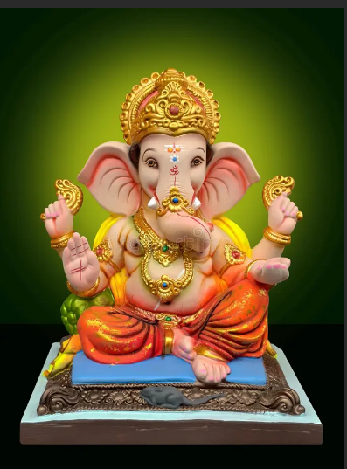
c) OUTPUT
